Business Unit
Mobile Failures Report
ASAP 7.0.2 – JAMU66

Weeks 33 - 40
August 13th to October 7th, 2018

October 12th, 2018

Contents

1 Percentages for all mobile activations, changes and deactivations Anguilla 3
2 Percentages for all mobile activations, changes and deactivations Antigua 4
3 Percentages for all mobile activations, changes and deactivations Barbados 5
4 Percentages for all mobile activations, changes and deactivations British Virgin Islands 6
5 Percentages for all mobile activations, changes and deactivations Cayman 7
6 Percentages for all mobile activations, changes and deactivations Dominica 8
7 Percentages for all mobile activations, changes and deactivations Grenada 9
8 Percentages for all mobile activations, changes and deactivations Jamaica 10
9 Percentages for all mobile activations, changes and deactivations Monserrat 11
10 Percentages for all mobile activations, changes and deactivations Saint Vincent 12
11 Percentages for all mobile activations, changes and deactivations Turks and Caicos 13
12 Percentages for all mobile activations, changes and deactivations Santa Lucia 14
13 Percentages for all mobile activations, changes and deactivations Saint Kitts and Nevis 15

Percentages for all mobile activations, changes and deactivations Anguilla

 | TOTAL | COMPLETE | FAILED | % Total | % COMPLETE | % FAILED
ACTIVATE | 410 | 409 | 1 | 20% | 100% | 0%
DEACTIVATE | 391 | 390 | 1 | 19% | 100% | 0%
MODIFY | 1256 | 1229 | 27 | 61% | 98% | 2%

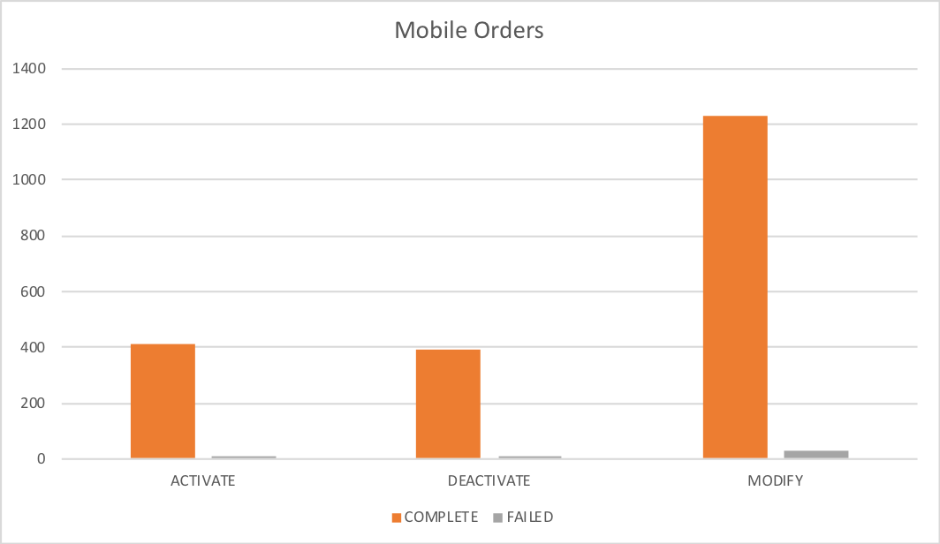

Percentages for all mobile activations, changes and deactivations Antigua

 | TOTAL | COMPLETE | FAILED | % Total | % COMPLETE | % FAILED
ACTIVATE | 2466 | 2322 | 144 | 16% | 94% | 6%
DEACTIVATE | 2627 | 2627 | 0 | 18% | 100% | 0%
MODIFY | 9882 | 9532 | 350 | 66% | 96% | 4%

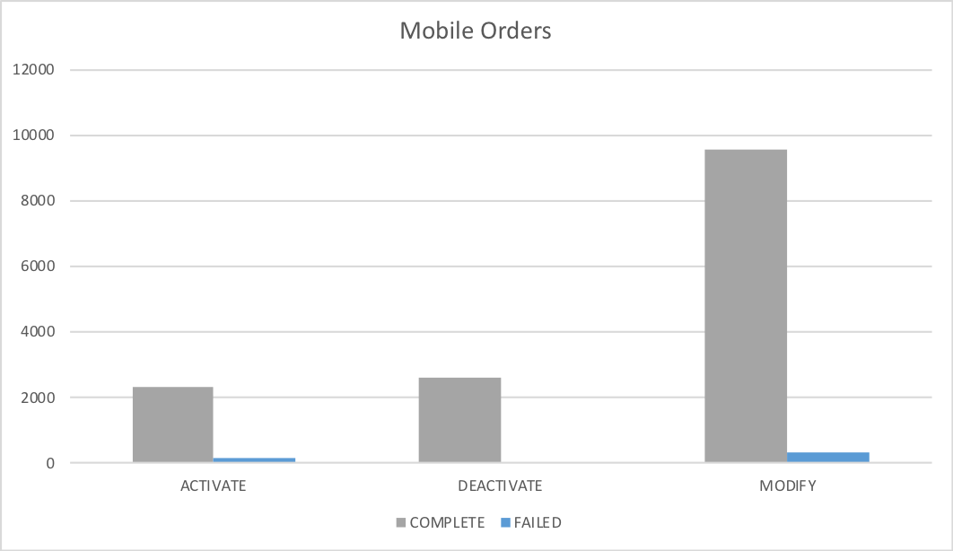

Percentages for all mobile activations, changes and deactivations Barbados

 | TOTAL | COMPLETE | FAILED | % Total | % COMPLETE | % FAILED
ACTIVATE | 7205 | 6794 | 411 | 23% | 94% | 6%
DEACTIVATE | 6431 | 6428 | 3 | 21% | 100% | 0%
MODIFY | 17146 | 16538 | 608 | 56% | 96% | 4%

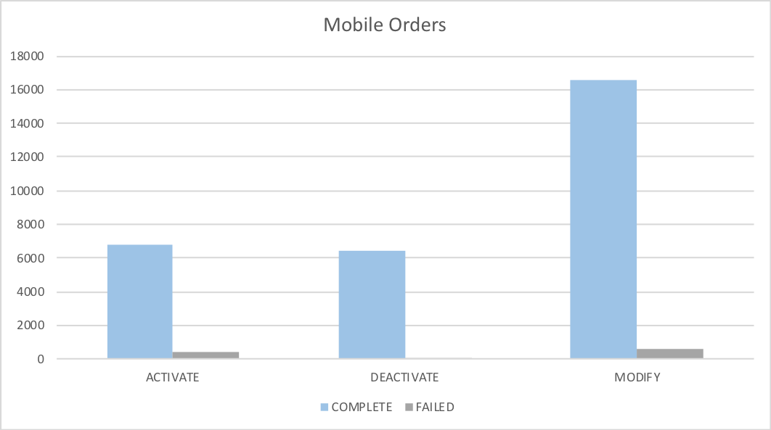

Percentages for all mobile activations, changes and deactivations British Virgin Islands

 | TOTAL | COMPLETE | FAILED | % Total | % COMPLETE | % FAILED
ACTIVATE | 1211 | 1210 | 1 | 8% | 100% | 0%
DEACTIVATE | 2597 | 2596 | 1 | 18% | 100% | 0%
MODIFY | 10989 | 10964 | 25 | 74% | 100% | 0%

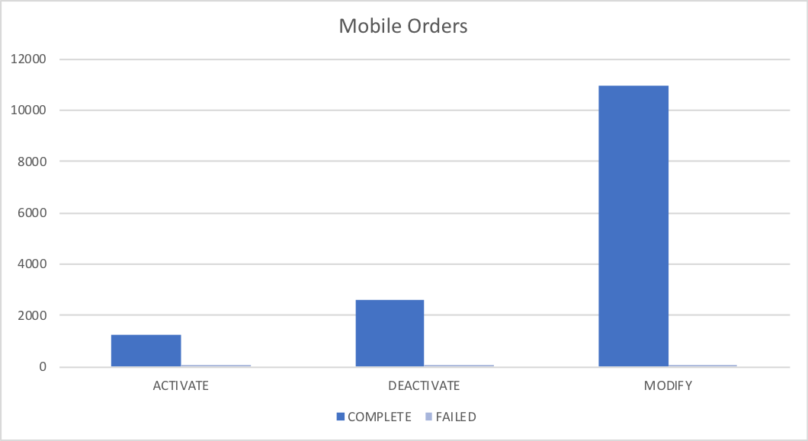

Percentages for all mobile activations, changes and deactivations Cayman

 | TOTAL | COMPLETE | FAILED | % Total | % COMPLETE | % FAILED
ACTIVATE | 1984 | 1966 | 18 | 6% | 99% | 1%
DEACTIVATE | 3158 | 3145 | 13 | 9% | 100% | 0%
MODIFY | 30787 | 30360 | 427 | 86% | 99% | 1%

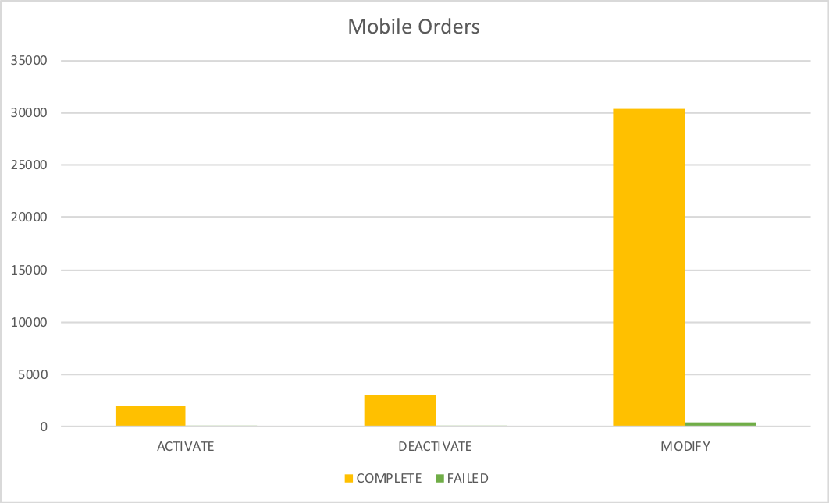

Percentages for all mobile activations, changes and deactivations Dominica

 | TOTAL | COMPLETE | FAILED | % Total | % COMPLETE | % FAILED
ACTIVATE | 4647 | 4609 | 38 | 24% | 99% | 1%
DEACTIVATE | 3188 | 3177 | 11 | 17% | 100% | 0%
MODIFY | 11250 | 11169 | 81 | 59% | 99% | 1%

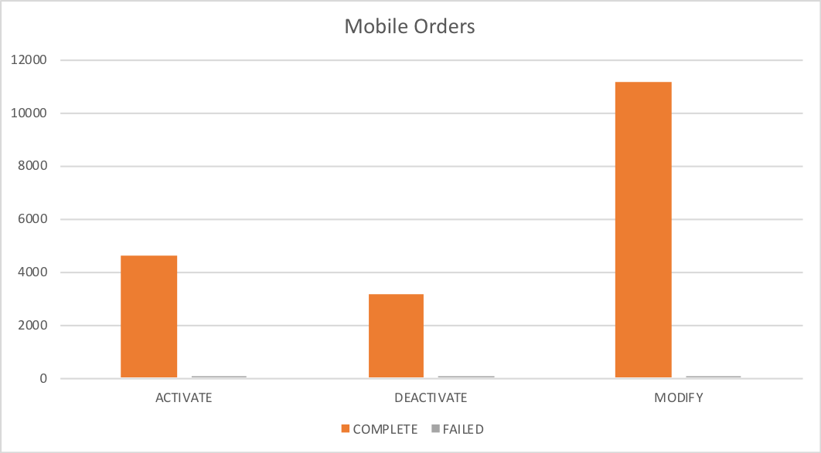

Percentages for all mobile activations, changes and deactivations Grenada

 | TOTAL | COMPLETE | FAILED | % Total | % COMPLETE | % FAILED
ACTIVATE | 1428 | 1427 | 1 | 11% | 100% | 0%
DEACTIVATE | 3158 | 3157 | 1 | 25% | 100% | 0%
MODIFY | 8129 | 8106 | 23 | 64% | 100% | 0%

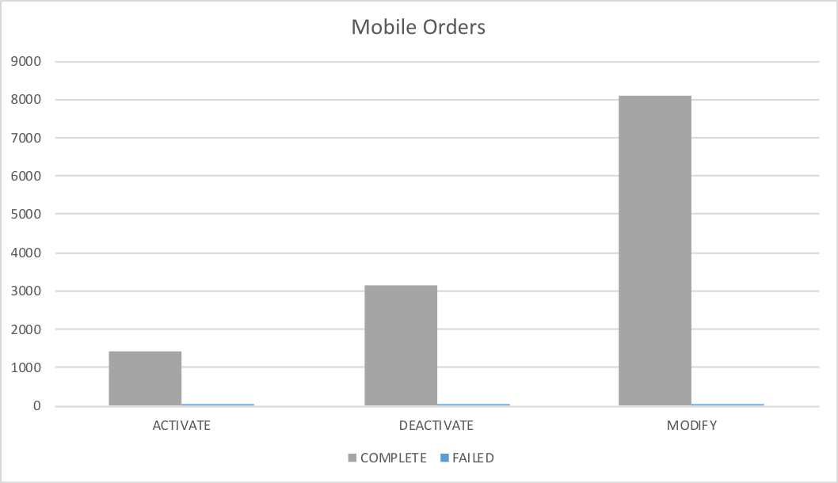

Percentages for all mobile activations, changes and deactivations Jamaica

 | TOTAL | COMPLETE | FAILED | % Total | % COMPLETE | % FAILED
ACTIVATE | 24566 | 24436 | 130 | 11% | 99% | 1%
DEACTIVATE | 47770 | 47739 | 31 | 22% | 100% | 0%
MODIFY | 143946 | 143526 | 420 | 67% | 100% | 0%

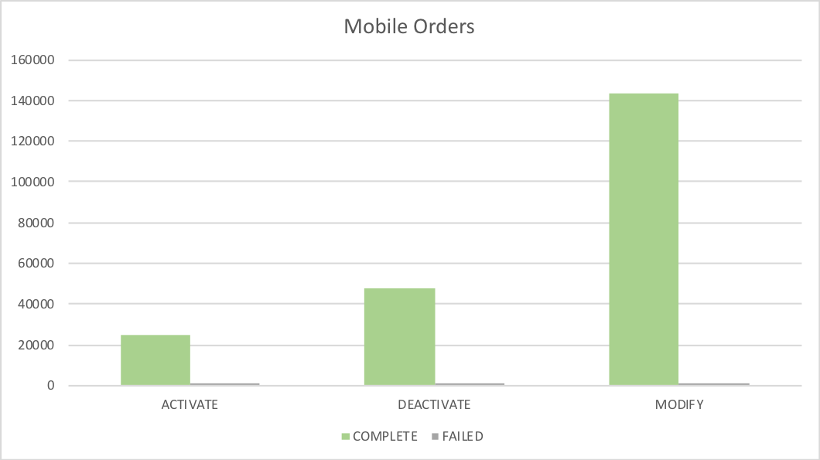

Percentages for all mobile activations, changes and deactivations Monserrat

 | TOTAL | COMPLETE | FAILED | % Total | % COMPLETE | % FAILED
ACTIVATE | 135 | 135 | 0 | 17% | 100% | 0%
DEACTIVATE | 174 | 174 | 0 | 22% | 100% | 0%
MODIFY | 499 | 496 | 3 | 62% | 99% | 1%

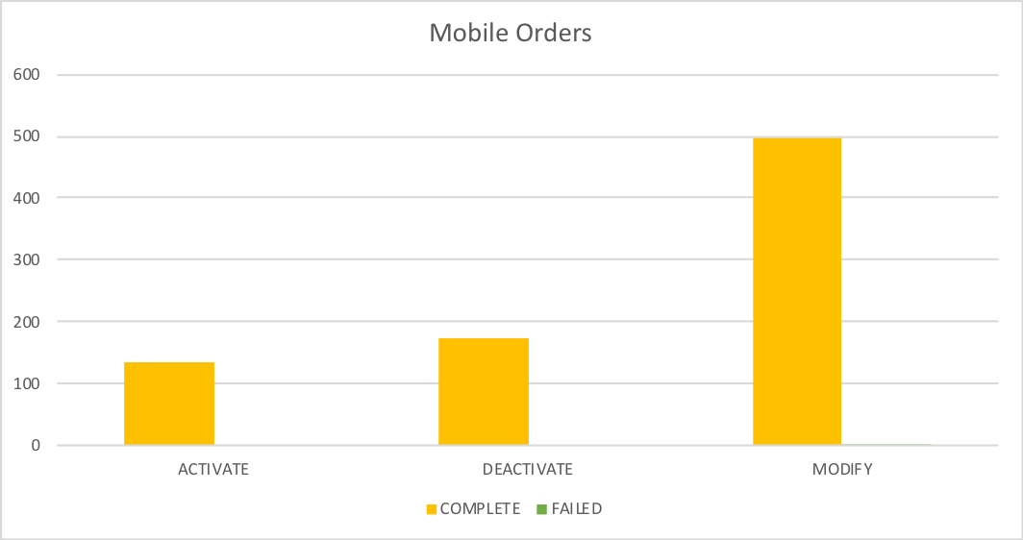

Percentages for all mobile activations, changes and deactivations Saint Vincent

 | TOTAL | COMPLETE | FAILED | % Total | % COMPLETE | % FAILED
ACTIVATE | 2256 | 2254 | 2 | 15% | 100% | 0%
DEACTIVATE | 4008 | 4008 | 0 | 27% | 100% | 0%
MODIFY | 8412 | 8381 | 31 | 57% | 100% | 0%

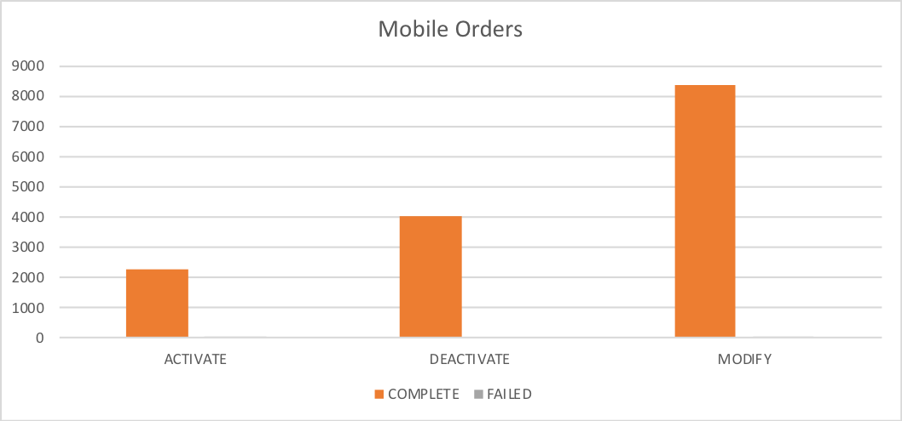

Percentages for all mobile activations, changes and deactivations Turks and Caicos

 | TOTAL | COMPLETE | FAILED | % Total | % COMPLETE | % FAILED
ACTIVATE | 1329 | 1239 | 90 | 12% | 93% | 7%
DEACTIVATE | 2479 | 2477 | 2 | 22% | 100% | 0%
MODIFY | 7605 | 7133 | 472 | 67% | 94% | 6%

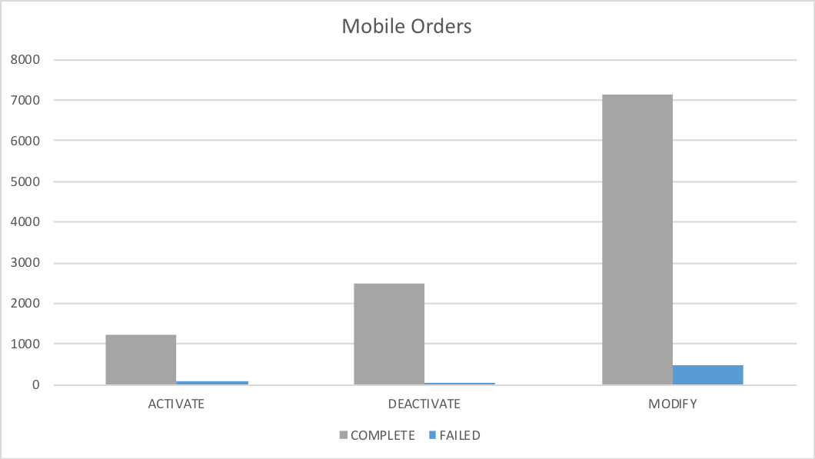

Percentages for all mobile activations, changes and deactivations Santa Lucia

 | TOTAL | COMPLETE | FAILED | % Total | % COMPLETE | % FAILED
ACTIVATE | 3419 | 3382 | 37 | 17% | 99% | 1%
DEACTIVATE | 3504 | 3499 | 5 | 17% | 100% | 0%
MODIFY | 13564 | 13477 | 87 | 66% | 99% | 1%

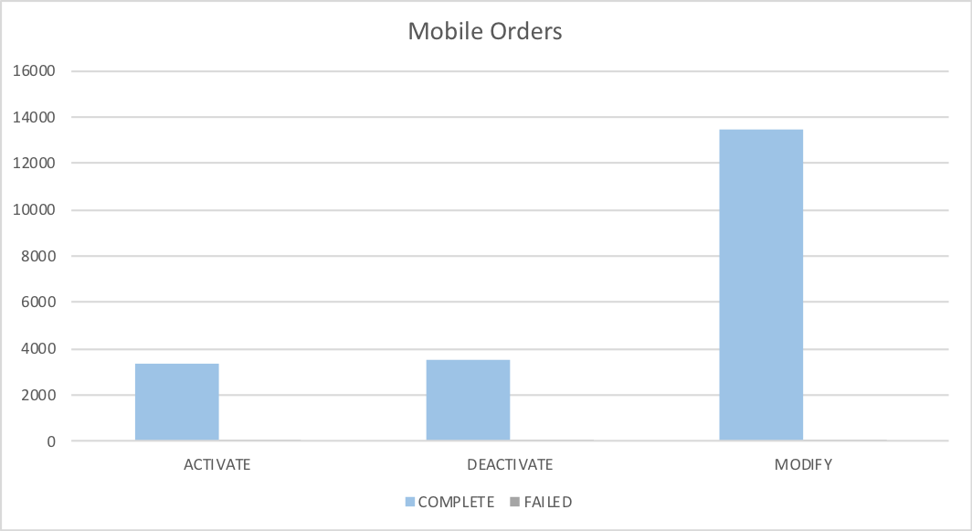

Percentages for all mobile activations, changes and deactivations Saint Kitts and Nevis

 | TOTAL | COMPLETE | FAILED | % Total | % COMPLETE | % FAILED
ACTIVATE | 1706 | 1654 | 52 | 17% | 97% | 3%
DEACTIVATE | 1790 | 1788 | 2 | 18% | 100% | 0%
MODIFY | 6292 | 6216 | 76 | 64% | 99% | 1%

